
___________________________________________________________________________
FACULTY OF COMPUTING
SEMESTER 1 2025/2026
___________________________________________________________________________
SECP3744 – ENTERPRISE SYSTEMS DESIGN AND MODELLING (WBL)
SECTION 1
TITLE:
ENTERPRISE SYSTEM DEVELOPMENT AND MANAGEMENT (ESDM) PROJECT

LECTURER: DR. ARYATI BINTI BAKRI

TABLE OF CONTENTS
LIST OF TABLES 4
LIST OF FIGURES 4
LIST OF ABBREVIATIONS 4
LIST OF APPENDICES 5
CHAPTER 1 6
1.1OVERVIEW 6
1.2PROBLEM STATEMENT 6
1.3PROJECT OBJECTIVES 7
1.4.1IN-SCOPE 9
1.4.2OUT-OF-SCOPE 9
1.5PROJECT IMPORTANCE 9
1.5.1 Strategic Alignment and Resources Optimization 10
1.5.2 Operational Efficiency and System Integration 10
1.5.3 Enhanced Student Experience 10
CHAPTER 2 11
2.1INTRODUCTION 11
2.2ENTERPRISE ARCHITECTURE 11
2.2.1UNIVERSITY OF LAMPUNG 12
2.2.2 NATIONAL UNIVERSITY SOUTH JAKARTA 14
2.3RELATED SUB-SYSTEM 16
2.3.1 Human Resources Management System (HRMS) 16
2.3.2 Academic Information System (AIS) 17
2.3.3 Student Information & Subject Registration System (SIS) and Learning Management System (LMS) 17
2.3.4 Business Intelligence (BI) and Data 18
2.4TECHNOLOGY USED 18
2.4.1 King Abdullah University of Science and Technology (KAUST) 19
2.5SUMMARY 20
CHAPTER 3 21
3.1INTRODUCTION 21
3.3PHASES OF METHODOLOGY 22
3.3.1 Requirements 22
3.3.2 Design 22
3.3.3 Development 23
3.3.4 Testing 23
3.3.5 Deployment 23
3.3.6 Maintenance 23
3.4PROJECT PLANNING SCHEDULE 24
3.5SUMMARY 25
CHAPTER 4 26
4.1INTRODUCTION 26
4.2COMPANY ORGANIZATION STRUCTURE 26
4.3CURRENT SYSTEM ANALYSIS 27
4.4SYSTEM REQUIREMENTS GATHERING 28
4.8SYSTEM DESIGN 31
4.8.1ENTERPRISE ARCHITECTURE EA – AS IS 31
4.8.2COMPONENT EXPLANATION OF ENTERPRISE ARCHITECTURE EA – AS IS 32
4.8.3ENTERPRISE ARCHITECTURE EA – TO BE 37
4.8.4COMPONENT EXPLANATION OF ENTERPRISE ARCHITECTURE EA – TO BE 38
4.8.5SYSTEM ARCHITECTURE 43
4.8.6PROJECT DESIGN 44
4.8.7DATABASE DESIGN 56
4.8.8INTERFACE DESIGN 57
4.9SUMMARY 59
CHAPTER 5 60
5.1INTRODUCTION 60
5.2SYSTEM DEVELOPMENT 60
5.3CREATE DATABASE 60
5.4CODING OF SYSTEM PROCESS 60
CHAPTER 6 61
6.1INTRODUCTION 61
6.2SYSTEM CONTRIBUTION 61
6.3SYSTEM CONSTRAINT 61
6.4FUTURE SUGGESTION 61

LIST OF TABLES

Table no. | title | page

LIST OF FIGURES

figure no. | title | page
Figure 3.1  Figure 3.2 | Waterfall Methodology Phases  Gantt Chart

LIST OF ABBREVIATIONS

-
-
-

LIST OF APPENDICES

appendix | title | page

CHAPTER 1
INTRODUCTION

1.1 OVERVIEW
Universiti Tun Hussein Onn Malaysia (UTHM) is a public higher education institution that manages diverse academic and administrative activities to support students, academic staff, and university management. These functions are supported by several core operational information systems that collectively form the university’s enterprise systems environment. As the scale and complexity of university operations increase, the need for structured coordination between business processes, information systems, and supporting technologies becomes more significant.
Currently, UTHM utilizes a basic form of enterprise architecture to support its information systems landscape. While this provides a general structure for system usage and management, it does not yet represent a comprehensive or formally defined enterprise architecture that fully aligns business needs with application, data, and technology layers. As a result, there is an opportunity to further develop and formalize the enterprise architecture to improve system integration, consistency, and long-term planning.
This project involves the development of a proposed enterprise architecture for UTHM that covers four core operational systems at the enterprise level. Each system is analyzed by a different project group to provide detailed architectural insights. The focus of this project is on Student Information System (SIS), with particular emphasis on the Student Course Registration subsystem, By applying enterprise architecture principles commonly used in higher education institutions, this project aims to propose a structured architectural model that supports clearer system alignment, improved information flow, and more effective management of student academic processes at UTHM.

1.2 PROBLEM STATEMENT
This section outlines the key problems that motivate the development of the proposed enterprise architecture for UTHM. It highlights current issues related to the existing enterprise architecture, associated inefficiencies, and potential risks affecting student-related systems. The discussion focuses on the Student Information System (SIS), particularly the Student Course Registration subsystem, to justify the need for a structured enterprise architecture approach.
1.2.1 Current Issues
UTHM utilizes multiple information systems to support its academic and administrative operations, including student related systems such as SIS. However, the enterprise architecture currently applied is basic and not formally documented as a comprehensive enterprise-wide model. As a result, the relationships between business processes, applications, data, and technology are not clearly defined across the university's core operational systems.
1.2.2 Inefficiencies
Due to the absence of a formalized and standardized enterprise architecture, coordination between systems may be inconsistent. System development and enhancement activities may be carried out independently by different units, leading to challenges in system integration and information flow. These inefficiencies are more apparent in student-related systems, where accurate data handling and process alignment are critical to supporting academic activities such as course registration.
1.2.3 Risks and Limitations
Without a clear architectural structure, the Student Course Registration subsystems under the SIS faces limitations in terms of scalability, and long-term planning. The lack of clear mapping between business requirements and system functions increases the risk of misalignment with UTHM broader academic and digital objectives. In addition, future system improvements may become more complex and harder to manage without a structured enterprise architecture to guide decision making.

1.3 PROJECT OBJECTIVES
The main objective for this project is to design and purpose an enterprise architecture for Universiti Tun Hussein Onn Malaysia (UTHM). The objectives will be focused on analyzing the current system environment, applying a structured enterprise architecture framework which is TOGAF framework, and supporting future enhancing management of university operations. The objectives of this project are as follows:
- To analyze the existing information system used by Universiti Tun Hussein Onn Malaysia (UTHM) including academic system, management system and others to gain greater understanding the current system environment and challenges.

- To design an Enterprise Architecture (EA) for UTHM by using TOGAF framework as a structured guideline to structure the business processes, applications, data, and technology

- To provide a structured architectural reference for future system improvement to make the system more manageable and systematic
1.4 PROJECT SCOPE
This section defines the project boundaries to ensure that this project is achievable within the given constraints. It clearly outlines the areas that covered by the project (in-scope) and the part that are not included (out-of-scope) particularly related to the proposed enterprise architecture for UTHM.

1.4.1 IN-SCOPE
The in-scope areas of this project include:
- Analysis the existing enterprise systems environment at UTHM such as overview of academic, student, and management-related system.

- Focus on the Student Information System (SIS) specifically the student Course Registration subsystem as main case study

- Design a proposed Enterprise Architecture for UTHM using the TOGAF framework as structured guideline that are covering key architectural layer such as Business, Application, Data and Technology Architecture

- Create an architectural models and documentation as a reference for improvement of the system UTHM in future.

1.4.2 OUT-OF-SCOPE
The out-of-scope areas of this project include:
- Development a system, coding or any related to implementation of proposed enterprise architecture.

- Perform a testing such as security testing and user acceptance testing of existing or proposed system.

- Evaluation of hardware, cost analysis, or budgeting related to system implementation.

1.5 PROJECT IMPORTANCE
The development of a formalized Enterprise Architecture (EA) for UTHM is critical to ensuring the university’s digital infrastructure can support its growing academic and operational demands. This project holds significant importance in three key areas:

1.5.1 Strategic Alignment and Resources Optimization
Currently, UTHM’s information systems operate in silos, which often leads to redundant spending where different faculties might procure separate software solutions for similar needs. This project is important because it utilizes the TOGAF framework to create a unified blueprint. By centralizing the architecture, the university can identify overlapping resources and streamline IT investments. This ensures that every ringgit spent on technology aligns directly with UTHM’s strategic objectives, reducing unnecessary costs, and fostering long-term sustainability.

1.5.2 Operational Efficiency and System Integration
The project addresses the critical issue of fragmentation within UTHM’s current environment. By proposing a structured architecture for the Student Information System (SIS), this project eliminates the inefficiencies caused by independent system development. It provides a standard reference for IT teams, ensuring that data flows seamlessly between the academic and administrative departments. This reduces data redundancy, minimizes the risk of integration errors, and simplifies the maintenance of complex university systems.

1.5.3 Enhanced Student Experience
Since the project focuses specifically on the Student Course Registration subsystem, its immediate importance lies in directly improving student experience. Course registration is a high-traffic process that frequently suffers from system congestion. A well-architected system ensures scalability, preventing system crashes during peak registration times. Furthermore, this architectural update aims to streamline the user interface, making the registration process more intuitive and less stressful for students.

CHAPTER 2
LITERATURE REVIEW

2.1 INTRODUCTION
This chapter presents a literature review related to enterprise architecture (EA) in universities, providing both theoretical and practical foundations for this study. This chapter begins with EA definition, key concepts, and some applications within higher education institutions. Meutia, Sulistiani, Budiarti, and Sari (2022) state that EA serves as a strategic framework that aligns business processes, information system, and technology infrastructure with organizational objectives, helping universities to manage complex operations and support digital transformation.
Besides, the review also highlights previous studies on EA in universities, emphasizing how EA frameworks have been implemented in universities to coordinate administrative, academic, and technical functions (Hindarto, 2023; Amin, Hussain, Daoud, Abu Bakar, & Ahmad, 2024). In addition, this chapter examines various subsystems, discussing the existing implementation and architectural considerations of these sub-systems. Furthermore, this chapter also explores the technologies used in EA and its sub-systems, including software platforms and architectural frameworks.
Finally, this chapter concludes with a summary of key findings from previous studies to establish a solid foundation for understanding EA in universities worldwide.

2.2 ENTERPRISE ARCHITECTURE
Enterprise Architecture (EA) is a method that an organization uses to plan the business and IT in a way that each will fit together well. Following the TOGAF standard, EA segments the organization into different segments to show how processes, information, applications, and technology support each other (The Open Group, 2018). EA also serves as a clear blueprint to map business goals to their supporting IT systems (Lankhorst, 2017). EA typically includes four sectors which are Business Architecture, Data Architecture, Application Architecture, and Technology Architecture (The Open Group, 2018). Together, it helps everyone understand how the organization works and how IT supports the organization.
In University, the Data Architecture layer is crucial, as they require high data quality and data organization for all aspects of their business, including students, staff, and research. Previous works indicate that universities often use a TOGAF framework for guidance, but they adjust it to their needs (Pedroso, 2021). Universities focus on management of organizational data, interoperability of organizational systems, accessibility, and security. However, challenges like different departments managing their own systems, legacy and outdated technologies, and a lack of trained EA professionals prevent them from implementing EA effectively. Thus, universities require good planning and teamwork for the successful application of EA.

2.2.1 UNIVERSITY OF LAMPUNG
A study by Nama and Kurniawan (2017) designed an adaptive IT infrastructure based on the enterprise architecture framework The Open Group Architecture Framework (TOGAF) Architecture Development Method (ADM) for the University of Lampung (Unila). The Academic Information System (Siakad) used by Unila, which has been operational for a long time, is not integrated with other applications such as finance, employee, and planning systems. This causes delays in gathering data when leaders or stakeholders request reports across the work unit.
Figure x shows the enterprise architect that was proposed to Unila. According to the study, the IT unit should be in charge of centralizing infrastructure management. In order to deliver a scalable, dependable, and flexible service, the unit must also implement security rules, data management and distributed system services and run the Disaster Recovery Center.
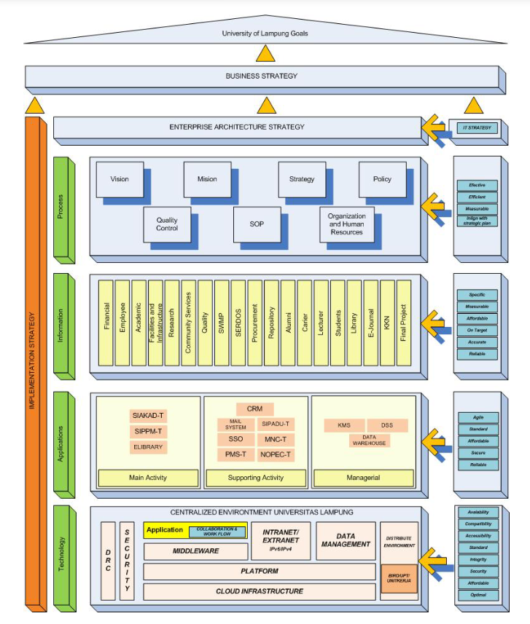
Figure x: Enterprise Architecture proposed to Unila. (Nama & Kurniawan, 2023)

2.2.2 NATIONAL UNIVERSITY SOUTH JAKARTA
Another study by Hidarto (2023) investigates the importance of EA in enabling digital transformation of the management systems in universities. The paper uses The Open Group Architecture Framework (TOGAF) framework as its research method, as it provides a methodical framework for the development, organization, execution, and oversight of enterprise information technology architecture. The paper defined digital transformation as the migration from manual processes to using application systems that can automate those processes, as universities often face problems such as human errors and slow information flow and data retrieval from manual processes. The paper also highlights opportunities using application systems such as access to advanced technologies, artificial intelligence (AI), big data analytics, and the Internet of Things (IoT) that can increase effectiveness in operation, boost the process of teaching and use resources efficiently.
Figure x shows the enterprise architecture described by the paper. The Integration Services establishes a connection to multiple sources, allowing data integration from external systems using API. The portal is a central interface through which teachers, staff, and students can combine their access to information and university resources. Data & Analytics oversees collecting, analysing, and using data to better decision-making, while the Back-Office systems manage the internal operations of the university.
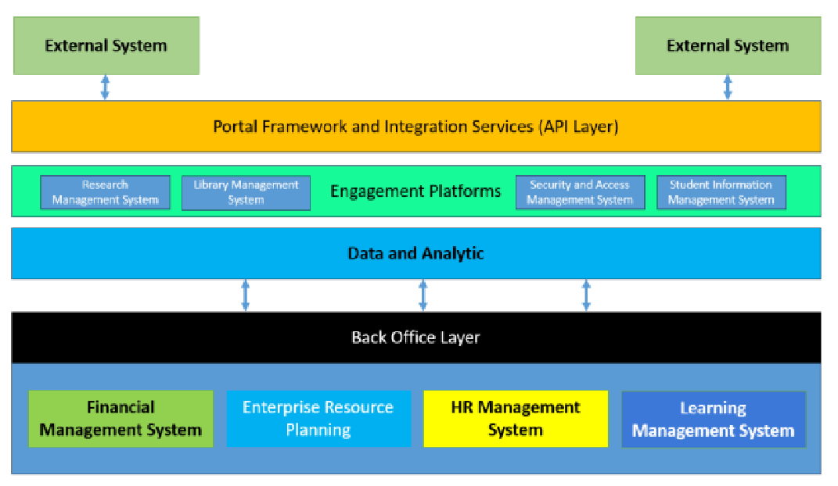
Figure x: Enterprise Architecture by Hidarto. Hidarto (2023)

2.3 RELATED SUB-SYSTEM
Research has been done to identify the subsystems used in university by analyzing them through the types of Enterprise Architecture methods and technologies. These studies look at the implementation and integration of systems like the Human Resources Management System (HRMS), Academic Information System (AIS), Student Information & Subject Registration System (SIS) and Learning Management System (LMS) and Business Intelligence (BI) and Data within EA frameworks to support coordinated processes, data consistency and higher education institutions’ operational and strategic goals.

2.3.1 Human Resources Management System (HRMS)
An HRMS is a system that combines information technology and human resources management (HRM) to automate and support HR procedures. For instance, it manages payroll, training, performance reviews, resignations, resume (applicant), employee details and attendance. The goal is to increase operational efficiency in HR departments, decrease manual work and make data access more dependable and simpler (Navaz et. al, 2013).

According to Sikarwa, 2018, the primary goal of HRMS is to guarantee that the organization’s strategic goals can be met and the universities’ needs can be satisfied in terms of both quantity and quality. The method used from the study is the Open Group Architecture Framework (TOGAF) 9.1 where it stated at preliminary phase; in addition to managing the standard data sources in universities like payroll, employee attendance, hiring and leave, HRMS also handles the demands of promotion management, period payment increase analysis, reward and punishment management and staff education. In particular, HRMS in universities mainly covers these functional areas including payroll management, human resources management, institutional management, civil service management, education and training management, performance management and function management. Furthermore, universities have a HRMS integrated system design that can be integrated with current systems so that its HRMS architecture may supply information required by end users as well as the business needs of universities in managing human resources.

2.3.2 Academic Information System (AIS)
A university’s Academic Information System (AIS) is a software program that keeps track of all academic data including timetables, grades, courses and student information. Students can access their transcripts, study result cards and academic information online while administrators can effectively manage student records, enter grades, manage courses and create reports. It replaces manual, paper-based procedures, saves time, minimizes mistakes and improves staff and student access to academic management (Manuhutu et. al, 2018).

According to Astri and Gaol, 2013, the academic information system manages the school’s academic processes from new student entrance to graduation ceremonies. In the study, this system performs essential functions such as managing admission test results, scheduling, curriculum, grade management, student administration and academic report applications. The study uses the Enterprise Architecture Planning (EAP) methodology to connect technology, data and apps across the systems. Hence, better administration, coordination and long-term system planning are made possible by the school’s ability to create a comprehensive blueprint through EAP that synchronizes its academic information systems with an integrated enterprise-level architecture.

2.3.3 Student Information & Subject Registration System (SIS) and Learning Management System (LMS)
The Student Information System (SIS) and the Learning Management System (LMS) constitute the core technological foundation that supports both academic administration and instructional delivery within a university. In contemporary digital transformation initiatives these systems are expected to function not as isolated components but as fully integrated parts of a comprehensive University Management System (UMS) (Hindarto, 2023).
The SIS is responsible for handling the complete lifecycle of student information. This includes initial registration, enrollment in subjects and the maintenance of academic records, and the management of graduation processes. Earlier forms of SIS frequently encountered issues such as fragmented datasets and duplicated entries which resulted in inconsistencies across institutional records (Lamey et al., 2023). To address these challenges many institutions, rely on EA frameworks that are often modelled on methodologies such as TOGAF. These frameworks enable the design of more coherent processes, unified databases, and stronger linkages to subsystems that include finance and scheduling (Metia et al., 2022).
The LMS complements the SIS by managing instructional resources and assessments. Effective academic operations require that the LMS maintain seamless integration with the SIS to ensure the accurate synchronization of enrollment data and student performance records. Lamey et al. (2023) emphasize that the development of intelligent and integrated academic solutions depends on consistent and harmonized data shared across both systems. Case studies demonstrate that EA planning (Nama and Kurniawan, 2017) plays a central role in shaping the Application Architecture layers to support reliable academic data flows.
2.3.4 Business Intelligence (BI) and Data
The Business Intelligence (BI) and Data Subsystems represent the strategic dimension of Enterprise Architecture implementation. Its purpose is to transform institutional data into reliable insights that guide decision making, policy information, and overall governance. A central objective of EA within digital transformation initiatives is to advance universities toward a fully data driven operational environment (Hindarto, 2023).
The effectiveness of any BI subsystem is determined by the strength of the Data Architecture established during the EA planning process. This stage involves the standardization of data definitions and the assurance of data quality throughout all primary source systems such as the SIS, HRMS, and FMS before these data are transferred into a centralized data warehouse (Meutia et al., 2022). Without rigorous data governance the outputs produced by BI platform risk becoming fragmented or unreliable.
According to Lamey et al. (2023) advanced analytical and intelligent institutional systems require a well-integrated and dependable data foundation. Such a foundation allows universities to perform tasks that include forecasting student retention, allocating resources efficiently, and monitoring institutional performance indicators. Consequently, the application of EA principles (Nama and Kurniawan, 2017) extends beyond merely connecting technological subsystems. It involves structuring the data environment in a way that supports meaningful strategic intelligence.

2.4 TECHNOLOGY USED
This section serves to describe and justify the key technological platforms, frameworks, and tools selected for the implementation of the enterprise system under study. This part highlights the infrastructure and digital solutions chosen for their relevance, effectiveness, or innovation, providing a clear rationale for why these technologies suit the project's goals and context. In this case of university enterprise systems, this section explains how foundational technologies like SAP Business Technology Platform (BTP) support the digital transformation of campus services and operations, allowing for centralized management, real time analytics, and seamless integration across diverse academic and administrative functions.

2.4.1 King Abdullah University of Science and Technology (KAUST)
The project uses the SAP Business Technology Platform as a central technological enabler, similar to the real-life implementation at King Abdullah University of Science and Technology. Building on SAP BTP, KAUST created an integrated digital platform called "KAUST Central," which consolidated the essential campus services-dining, transportation, security, payments, and communication-into one mobile and web application. The system is exemplary, depicting how SAP BTP can enable a university-wide digital transformation through scalable cloud services, intelligent integration, and user-centered design.
Several SAP BTP components were leveraged for the KAUST project. SAP Mobile Services SDK was used to build native apps for iOS and Android, thus allowing real-time access to campus functions. SAP Analytics Cloud allowed data-driven decisions based on tracking student behavior and providing personalized content, while SAP Experience Management (Qualtrics) continuously gathered user feedback for refining campus services. Moreover, the SAP BTP cloud infrastructure enabled seamless integrations with legacy systems and third-party applications through standardized APIs, which is very important in a distributed university setting where various departments operate on different platforms.
From an enterprise architecture perspective, with SAP BTP, KAUST has implemented a modular and flexible architecture scaling across departments while preserving centralized governance. Single sign-on simplified access to the system, while the cloud-native setup provided support for rapid updates and extensions, such as adding COVID-19 information features and smart city modules. Most impressively, the platform has managed to cut campus services' wait times from 10 minutes down to 40 seconds and allowed logistics, dining, and transport on campus to be coordinated through real-time dashboards and automated processes.
The use of SAP BTP at KAUST represents one way in which universities are moving beyond traditional ERP models toward a campus-as-a-platform model. It confirms SAP BTP as appropriate, future-ready technology for university enterprise systems, which supports digital innovation, integration, analytics, and smart campus ecosystems.

2.5 SUMMARY
The literature review highlights the importance of Enterprise Architecture (EA) in helping universities to align their business procedures, data management, applications, and technology infrastructure to meet institutional goals and digital transformation. Previous studies show that universities often adopt EA frameworks such as TOGAF framework, but universities usually adjust the framework so that they could fit their own needs, especially when dealing with issues such as decentralized departments, out-dated systems, and diverse stakeholder needs.
Case examples from University of Lampung demonstrate how EA can support better alignment between strategy and IT, improve data management, integrate applications, and set clear technology standards. Meanwhile, insights from the National University South Jakarta emphasize that universities often change from manual processes to digital transformation using application systems that can automate those processes.
In addition, the review of key university sub-systems, including HRMS, AIS, SIS, LMS, BI, and Data shows how EA helps universities ensure smooth data flow, reduce duplication, and design scalable systems. Furthermore, the use of technologies, such as SAP Business Technology Platform (BTP) as demonstrated by KAUST, further show how cloud-based platforms enable universities to deliver smart campus services and support long-term digital innovation.
In conclusion, the literature establishes EA as a strong foundation for modern university enterprise systems, providing both strategic direction and technology integration to enhance overall institutional performance.

CHAPTER 3
METHODOLOGY

3.1 INTRODUCTION
This project aims to design an enterprise architecture for Universiti Tun Hussein Onn Malaysia (UTHM). To achieve this goal, the Waterfall development approach is adopted in this project. The methodology guides the development process of this project from starting to the end, which is planning, analysis, design, implementation, and testing the enterprise architecture components. By following the methodology, the project ensures that every phase of the methodology was implemented successfully and aligned with UTHM operational requirements.

3.2 CHOSEN METHODOLOGY
The Waterfall methodology is a sequential development process where every phase must be completed before moving on to the next phase. It is suitable to be applied in projects that have clear and fixed requirements.
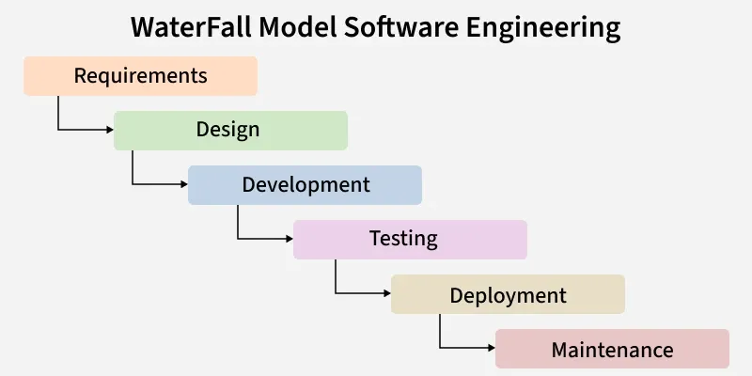
Figure 3.1 Waterfall Methodology Phases (GeeksforGeeks, 2025)
The reason why Waterfall methodology is chosen is because of its structured flow. Since enterprise architecture involves complex systems and long-term planning, understanding the correct requirements is very important. With this methodology, all requirements must be clearly understood before moving to next phase to design the real enterprise architecture.
Other than that, each phase in the Waterfall approach such as requirements analysis, design, implementation, and testing is clearly documented. These documentations will help the university a lot in future maintenance or enhancement.
Moreover, since the phases are clearly defined, it is easier to manage resources, manpower, and project schedules. This reduces uncertainty of the project and reduces the risk of project failure. Therefore, the Waterfall methodology is a suitable approach for this project.

3.3 PHASES OF METHODOLOGY
As illustrated in Figure 3.1, this project is led by the six distinct phases of the Waterfall Model. Each phase depends on the deliverables of the previous one, making sure of a logical progression from recognizing the fragmentation issues at UTHM to delivering an interrelated Enterprise Architecture blueprint.

3.3.1 Requirements
The first phase involves gathering and analysing the necessary information to understand the current state of UTHM’s business and IT environment specifically identifying pain points caused by the separation of various departmental systems. In this stage, the project team conducts data gathering to understand the existing siloed systems across different faculties and administrative units, defining the scope for unifying these departments into a single platform. The outcome of this phrase is a comprehensive Problem Statement and User Requirement Specification (URS) that clearly identifies the gaps in the current architecture.

3.3.2 Design
Based on the requirements gathered, the team moves to the design phase to create the architectural blueprints that define the “To-Be” state of the organization. The team adopts the TOGAF (The Open Group Architecture Framework) approach to model the target architecture including the Business, Data, Application, and Technology layers required to support a unified university platform. This phase concludes with the production of high-level architectural diagrams and a proposed Enterprise Architecture design document that solves the issues identified in the analysis phase.

3.3.3 Development
Since this project focuses on proposing a blueprint rather than building software, the development phase involves the detailed construction of the architectural solution and the strategic roadmap. The team develops the Transition Architecture, defining the standards and logical specifications required to bridge the gap between the current disconnected systems and the proposed unified platform. The primary deliverables from this phase are a complete EA Implementation Plan and a detailed migration strategy.

3.3.4 Testing
Before the architecture is finalized, it undergoes a verification process to ensure it aligns with UTHM’s operational goals and technical standards. The proposed blueprint is validated through an Expert Review process, where the team presents the architectural design to the UTHM Data Officer to verify that the unified data models and integration strategies are feasible and accurate. This phase produces a validation report and a summary of feedback from domain experts to confirm the architecture addresses the identified gaps.

3.3.5 Deployment
Once the design is verified, the architecture is ready for delivery to the stakeholders. The final Enterprise Architecture proposal is formally presented to the university management, marking the transition from planning to potential adoption. For this project, this phase represents the submission of the final project report and the formal presentation of the unified platform proposal.

3.3.6 Maintenance
The final phase focuses on the long-term sustainability of the architecture. Although this project concludes upon submission, this phase outlines recommendations for future governance to ensure the unified platform remains adaptable to new educational technologies or changes in UTHM’s strategic direction. The key output here is a set of recommendations for future architecture governance and scalability.

3.4 PROJECT PLANNING SCHEDULE
The project planning schedule, as illustrated in Figure xx, follows the sequential stages of the Waterfall methodology to ensure a structure development process. The timeline begins with a collective planning and analysis phase, where the entire team conducts a site visit to UTHM and prepares interview questions to define the system requirements. The project moves into design phase, where individual responsibilities are assigned to all team members to develop specific tasks for the seven modules. The schedule then transitions into the implementation phase, focusing on database creation, and coding. Finally, the process concludes with a testing and deployment phase.
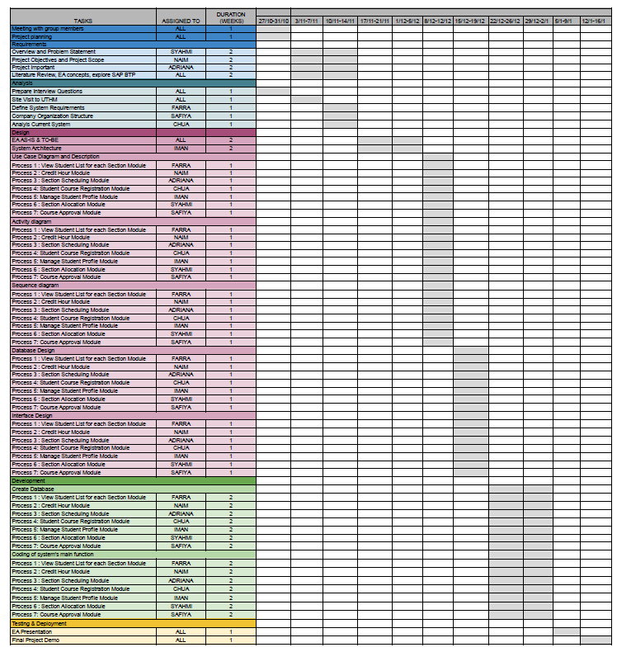
Figure 3.2: Gantt Chart

3.5 SUMMARY
The enterprise architecture for Universiti Tun Hussein Onn Malaysia (UTHM) is developed using the Waterfall methodology, which follows a structured and sequential development process. This approach organizes the project into clear phases, including planning, analysis, design, implementation, and testing, ensuring that each stage is completed before moving forward and remains aligned with UTHM operational requirements.
The Waterfall methodology is suitable for this project because enterprise architecture involves complex systems, and long-term planning that require clearly defined requirements. Understanding all requirements at the early stage helps reduce the risk of system misalignment and improves the quality of architectural design. In addition, clear documentation produced in each phase supports future system maintenance and enhancement activities.
The project planning schedule follows the sequential flow of the Waterfall model, beginning with site visits and requirement analysis. The process then moves into the design phase, where responsibilities are distributed among team members, followed by implementation activities such as database creation and the use of framework such SAP Build. The project concludes with testing and deployment to ensure the proposed enterprise architecture functions as intended within the university environment.

CHAPTER 4
ANALYSIS AND DESIGN

4.1 INTRODUCTION
This chapter’s focuses on the design and analysis of the proposed system and the Enterprise Architecture (EA) for Universiti Tun Hussein Onn Malaysia (UTHM). It looks at the current system to find issues and requirements followed by the right enterprise architecture and system design approaches to create an improved EA. This chapter’s outputs include the system architecture, database design and interface design to offer a clear foundation for the EA implementation stage.

4.2 COMPANY ORGANIZATION STRUCTURE
The Information Technology Centre (PTM) at Universiti Tun Hussein Onn Malaysia (UTHM) operates under a structured hierarchy led by a Director and a Senior Deputy Director, supported by an Office Secretary Assistant. The department is organized into six main divisions that handle different parts of the university’s technology needs. The Application Management Division is responsible for the Application Development Unit and the Student and Staff Information System Unit. Infrastructure and Cyber Security handles data centre, networks, and telecommunications.
The Digitalization Technology, which handles web and multimedia services, and ICT Facilities and Support, which manages technical help and campus equipment. To ensure projects follow university rules, the Governance, Strategic, and ICT Training oversees planning and staff training. Finally, the Administration and Finance division manages the department’s budget and office operations.
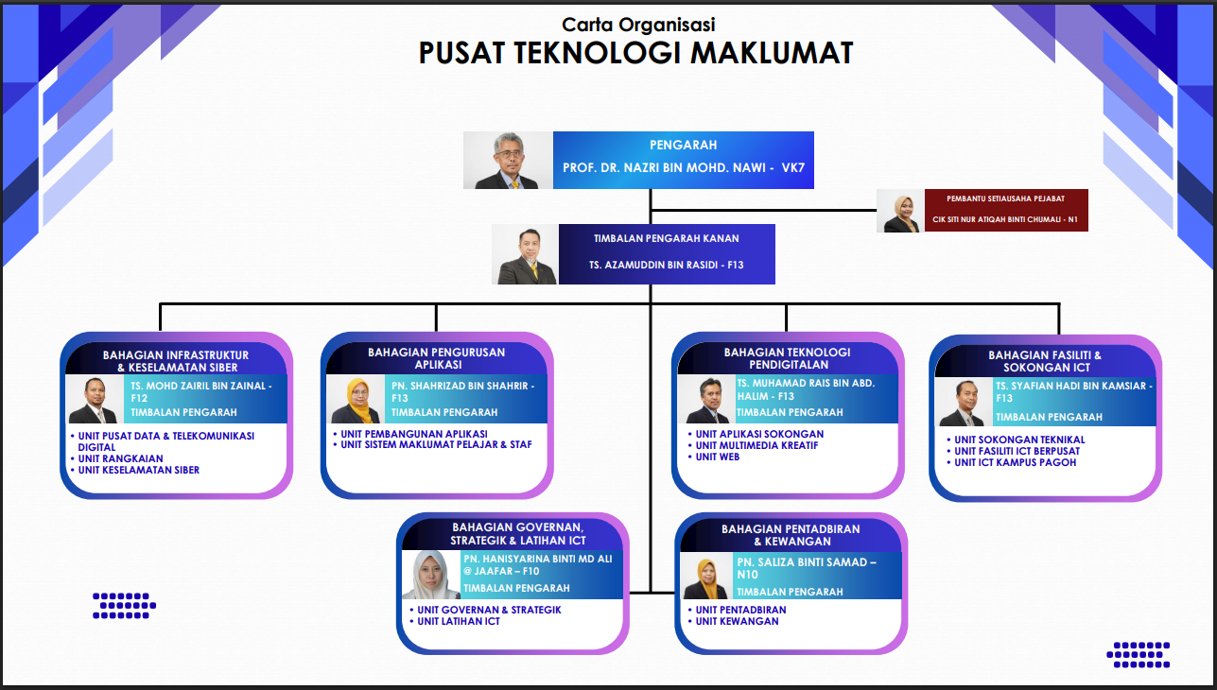Figure 4.1 Organization Chart of Information Technology Centre (PTM) at Universiti Tun Hussein Onn Malaysia (UTHM)

4.3 CURRENT SYSTEM ANALYSIS

UTHM currently uses a combination of limited manual processes and computerized systems. Their digital operations are supported by a Tier 3 infrastructure. The data center uses Data Structure Infrastructure Management (DCIM) monitoring, air-based condenser cooling system and hot and cold aisle containment to track performance and reduce power consumption. Additionally, they have a staging area where vendors set up systems before entering the containment area.

Furthermore, UTHM’s primary digital technologies include a central student database and Learning Management System (LMS) for teaching materials. These systems are not fully integrated so the majority of data transfers are carried out manually one at a time especially when the format or structure varies between the systems. However, API connections are used to manage big data transfers to increase efficiency and lower errors. The process was also carried out for data replication to the Data Recovery Center (DRC) where data is transmitted for disaster recovery to a DRC in Pagoh. Moreover, Single Sign-On (SSO) was implemented to make system access easier but frequent user concerns like forgotten password and Wi-Fi login issues still happen.

Additionally, UTHM is transitioning from old systems to a new web-based integrated system called Total Campus Integrated System (TCIS). This migration is ongoing and being completed phase by phase based on modules. Even though UTHM wants to be entirely digital by 2030, some administrative tasks are still done manually because of outdated equipment and legacy systems. They stated that some hardware comes with outdated operating systems which makes it less compatible with modern technologies. In addition, UTHM uses a WAF (Web Application Firewall) to secure web portals and websites as well as two firewalls which filter threats often from China and another from Europe to protect the system and data.

Overall, UTHM is actively pursuing digital transformation and has built a strong infrastructure. However, system integration, manual data handling, legacy equipment and user access continue to be challenges in achieving full end-to-end digital transformation by 2030.

4.4 SYSTEM REQUIREMENTS GATHERING
System requirements gathering is the process by which we gather data to understand user needs and the enterprise system that will be developed. It helps us to determine what functions, features and improvements are needed. Two methods were used to collect data for this industrial visit which are questionnaire and interview. Before visiting UTHM, a set of Enterprise Architecture related questions was prepared based on the TOGAF elements. Moreover, we asked the presenter directly during the talk session in order to gather more information. Below are the sample questions that were presented using the TOGAF elements:

1. Business Architecture
- What are the university’s primary business capabilities (e.g., teaching, research, finance, HR)?
- What is the top 10 business processes that require transformation?
- Which processes are manual, duplicated, or inefficient in the current environment?
- ⁠What future state vision or strategic goals does UTHM want the new EA to support?
- ⁠What are the critical KPIs (student success, research productivity, operational efficiency)?

2. Data Architecture
- What core data entities exist (students, staff, courses, finance, research, facilities)?
- ⁠What data standards or naming conventions does UTHM currently use?
- ⁠Where is data duplicated across systems?
- Is there single master database in UTHM for student data or separate with student database and learning database?
- What current workflow transferring between student data to LMS from the master database?

3. Application Architecture
- ⁠What are the current enterprise systems in use (student system, finance system, LMS)
- ⁠What functions do these systems provide today?
- ⁠What functions are missing?
- ⁠What is the most common complain receive from student for current online portal?
- ⁠What is the desired future application landscape (modular, unified, cloud-based)?

4. Technology Architecture
- What is the current hosting model (on-premises, cloud, hybrid)?
- ⁠Which operating systems, databases, and middleware solutions are used?
- ⁠What hardware or infrastructure is aging or needs replacement?
- ⁠What is the preferred technology stack for the new system?
- What precaution steps will be taken if electric is cut off?

5. Integration / Inoperability Architecture
- What systems need to integrate with each other (student system ↔ LMS ↔ finance)?
- ⁠What integrations currently exist, and what issues do they have?
- What is the strategy for data migration?

6. Security Architecture
- What are the authentication requirements (SSO, MFA, LDAP/Active Directory)?

7. Information / Content Architecture
- How are files stored today (file servers, Google Drive, departmental systems)?

8. Infrastructure Architecture
- How many data centres does UTHM operate?
- ⁠What backup and recovery processes are in place?

9. Governance Architecture
- Who makes decisions about IT investments and architectures?
- ⁠Does the university need EA governance tools (e.g., architecture repository)?
- Who will be responsible for reviewing or approving the system?

10. Change Management & Implementation Architecture
- How ready are stakeholders for digital transformation?
- ⁠What departments are most resistant to change?

4.8 SYSTEM DESIGN
This section describes the design of the proposed system based on the requirements identified during the analysis phase. The system design is presented using enteprise architecture models, system architecture, UML diagrams, database design and interface design to clearly illustrate how the system is structured, user-friendly and capable of improving the efficiency of the existing prosesses at UTHM.

4.8.1 ENTERPRISE ARCHITECTURE EA – AS IS

Figure x illustrates the AS-IS enterprise architecture of UTHM. The figure was designed based on the requirements gathered during an interview session with their representatives. The architecture was designed according to their business goals, limitations and constraints specified by them during the interview. Each component of the EA will be discussed on the following sub chapters.
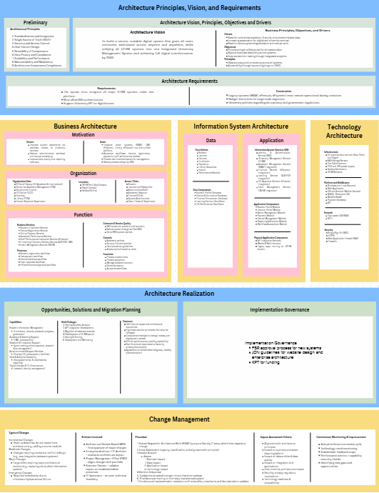
Figure x

4.8.2 COMPONENT EXPLANATION OF ENTERPRISE ARCHITECTURE EA – AS IS

Figure x shows the diagram that illustrating the architectural principles, visions and requirements. The primary goal of this design is to accomplish complete digital transformation by 2030. This is built on a goal to create a secure, scalable, and unified Integrated University Management System that offers all users uniform web-based access from anywhere. Several business reasons are driving this change, the most important of which is the necessity to combine distributed academic and financial data, as well as the growing demand for digital services. UTHM hopes to provide a single interface for all stakeholders, minimizing manual effort and boosting decision-making through integrated analytics.
To ensure that the system has a strong structure, the preliminary phase develops nine basic architectural concepts. These serve as the "base rules" for development, stressing standardization and integration, as well as a single source of truth (SSOT) to avoid data silos. The principles also focus the user experience through user-centric design while ensuring long-term sustainability through maintainability, modularity, and reusability. Security is a non-negotiable component, with a particular emphasis on data privacy, compliance, and access control, to ensure the architecture stays controlled and legally sound.
The current Architecture Vision (AS-IS) is primarily driven by operational stability and department independence rather than a unified enterprise strategy. It focuses on maintaining the functionality of distinct legacy systems like SMAP and ePayment to ensure daily academic and administrative continuity, relying on established on-premises infrastructure and manual data synchronization to meet immediate, localized business needs without disrupting ongoing university operations.
The effective execution of this vision is dependent on achieving architecture requirements, such as integrating all key existing UTHM systems and implementing Single Sign-On (SSO) for smooth user authentication. However, these objectives must be balanced against real-world constraints. Developers must guarantee that essential legacy systems, such as SMAP, ePrestasi, and ePayment, remain fully functioning during the transition phase. Furthermore, the change must be completed within the constraints of the university's budget and tight government data protection requirements.

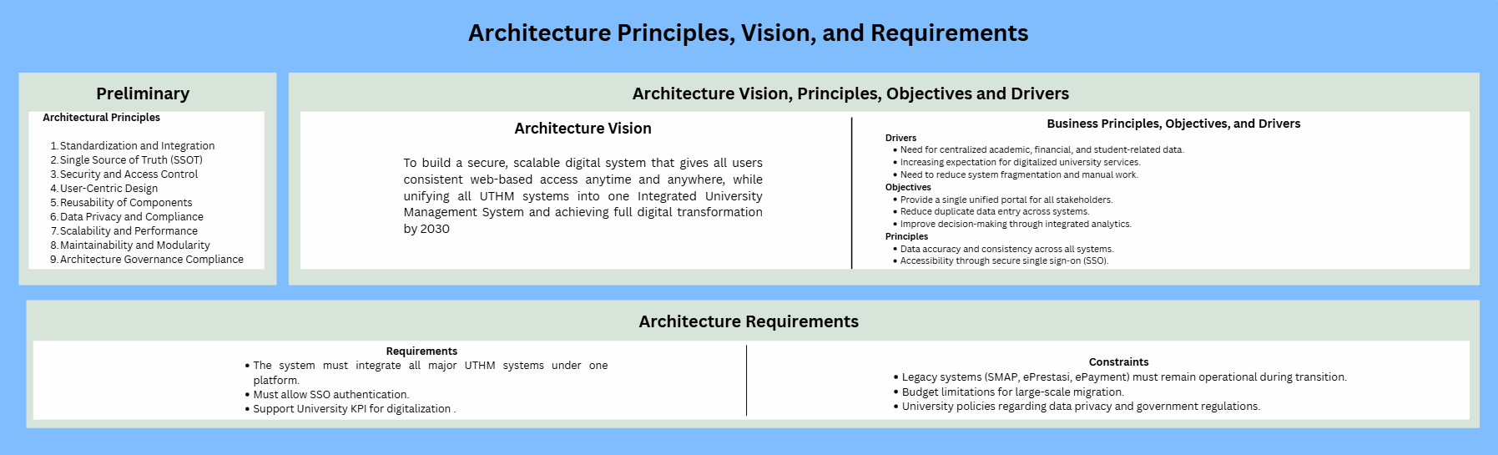
Figure x illustrates the business architecture, information systems architecture and the technological architecture in the EA. The business architecture layer is the foundation, outlining the motivation, organization, and function of the university's digital transformation. It is driven by its goal to improve student experiences while reducing administrative costs by integrating significant systems such as SMAP and LMS. An important performance aim is to cut process delays by 50% while maintaining 99% system uptime. This layer distinguishes between different organizational units, such as the ICT Center and the Bursary, and describes the responsibilities of individuals ranging from students and lecturers to system administrators. Functionally, it defines basic services such as student enrollment and fee collection, which are guided by academic and financial rules to ensure high standards of service.
This information system architecture defines the gap between business needs and technological execution by focusing on data and application components. Data architecture specifies the important entities such as students, lecturers and courses, in addition to the underlying data components, such as the student profile and financial transaction databases, which contain this information. The application architecture describes the Information System Services (ISS), which include the University Management Service (U-IMS) and particular modules for students and teachers. It focuses on the integration of historical systems (such as ePayment and ePrestasi) via an API integration layer, guaranteeing that disparate software components may efficiently communicate under a single site.
The Technology Architecture defines the physical and logical infrastructure needed to support the above levels. The infrastructure is created on-premises data centers in Batu Pahat and Pagoh, with Tier 3 architecture and SAN storage servers to provide high availability. The Platform and Middleware section includes information about Windows and Linux platforms, MySQL databases, and iOS and Android mobile compatibility. This complete stack is linked by high-speed LAN/WAN and Wi-Fi networks. The design protects university data with powerful security methods such as Web Application Firewalls (WAF), HTTPS encryption, and Single Sign-On (SSO).
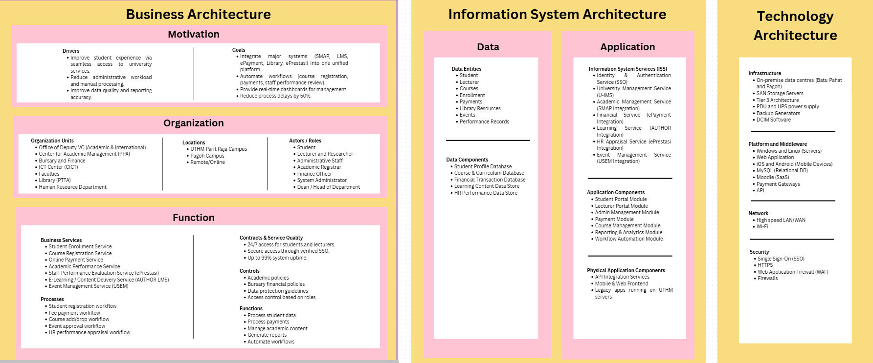The below EA AS-IS diagram shows the current situation of UTHM’s enterprise systems. At present, UTHM already has important capabilities such as Student Information Management, Academic Support, Administrative Services, data & Analytics, and IT Infrastructure. However, many of these systems still work separately. Some processes depend on manual work, and system integration is limited. Because of this, data sharing between systems can be slow, and it is harder for the university to monitor performance and make quick decision. This situation creates an opportunity to improve efficiency and reduce system duplication.
From the migration planning perspective, the AI-IS stage focuses on basic analysis and preparation. The work packages mainly involve existing system analysis, initial API integration, and testing. These steps help UTHM understand which systems need improvement and how they can be connected. The contracts section highlights the importance of defining system boundaries, security requirements, and performance indicators before any major changes are made. Overall, the AS-IS architecture helps UTHM identify weaknesses in the current environment and prepares the university for a more structured transformation.
As shown in Figure XX, the Implementation Governance framework for UTHM’s current enterprise architecture is defined by a structured oversight mechanism designed to ensure that all technical developments align with both internal policies and national standards. The governance process is anchored by three primary pillars which are the FSR approval process for the validation of new systems, the JDN (Jabatan Digital Negara) guidelines which standardize website design and enterprise architecture practices, and KPT (Ministry of Higher Education) for the strategic oversight of project funding. This framework ensures that any architectural changes, whether incremental or major, remain compliant with institutional mandates while maintaining the operational integrity of critical legacy systems.
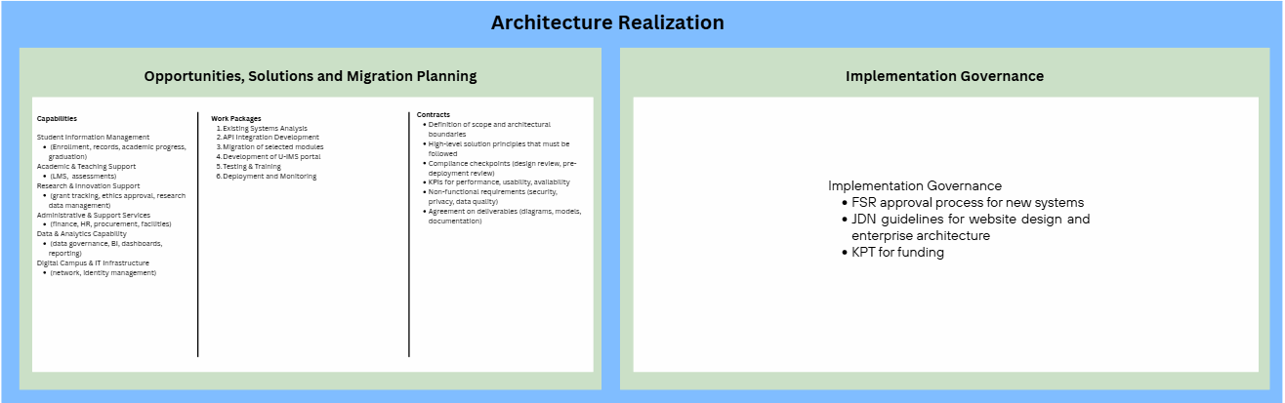

Figure x shows the change management component within the EA. The Architecture Change Management (Phase H) creates a governance structure to guarantee that the university's digital systems change in an organized way rather than through random changes. It divides modifications into three categories: process simplification, gradual process incrementation, and system redesign. This guarantees that minor enhancements are implemented quickly, while high-impact changes are examined with extensive evaluation required to preserve system reliability and security.

The Architecture Review Board (ARB) manages the process, which is started by a formal change request if there are new technologies or changes in business needs. Each proposal must go through an extensive impact analysis to determine its impact on data integrity, current integrations, and the user experience. This phase ensures that all technological evolutions stay firmly connected with the university's long-term strategic strategy for 2030 by requiring official permission prior to execution.

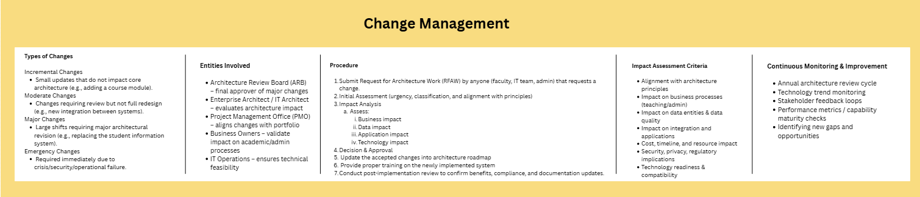

4.8.3 ENTERPRISE ARCHITECTURE EA – TO BE

Figure x below shows the proposed TO-BE enterprise architecture. It serves as the blueprint for UTHM on the proposed recommendations that can be improved based on the AS-IS enterprise architecture that still aligns with their business while at the same time improving efficiency. Some components have changes based on recommendations to improve business model while some principles remain the same.
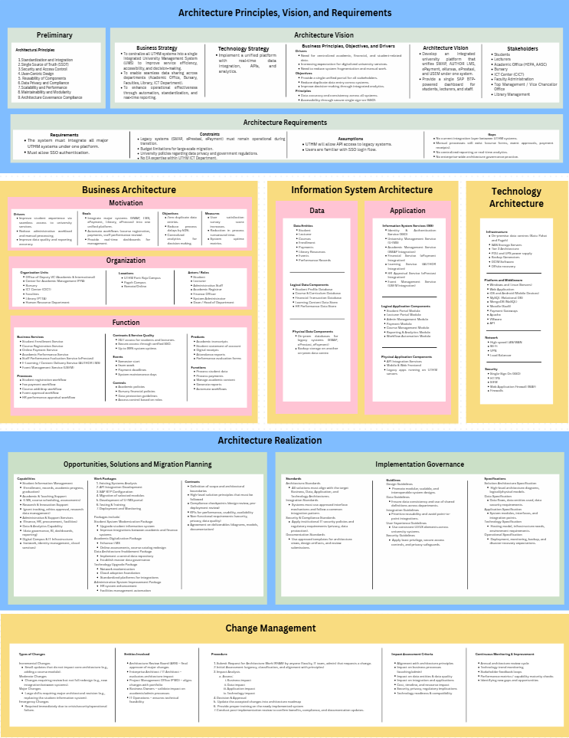

4.8.4 COMPONENT EXPLANATION OF ENTERPRISE ARCHITECTURE EA – TO BE
Figure shows the diagram that illustrating the architectural principles, visions and requirements. The primary goal of this design is to accomplish complete digital transformation by 2030. This is built on a goal to create a secure, scalable, and unified Integrated University Management System that offers all users uniform web-based access from anywhere. Several business reasons are driving this change, the most important of which is the necessity to combine distributed academic and financial data, as well as the growing demand for digital services. UTHM hopes to provide a single interface for all stakeholders, minimizing manual effort and boosting decision-making through integrated analytics.
To ensure that the system has a strong structure, the preliminary phase develops nine basic architectural concepts. These serve as the "base rules" for development, stressing standardization and integration, as well as a single source of truth (SSOT) to avoid data silos. The principles also focus the user experience through user-centric design while ensuring long-term sustainability through maintainability, modularity, and reusability. Security is a non-negotiable component, with a particular emphasis on data privacy, compliance, and access control, to ensure the architecture stays controlled and legally sound.
The proposed Architecture Vision (TO-BE) aims to realize UTHM’s Digital Transformation 2030 agenda by establishing a unified, cloud-enabled Smart Campus ecosystem. This vision shifts the strategic focus towards high interoperability and a Single Source of Truth (SSOT), leveraging technologies like SAP Build Apps and SIEM to create a semaless, secure, and user-centric environment that integrates all academic and management functions functions into a single, scalable platform.
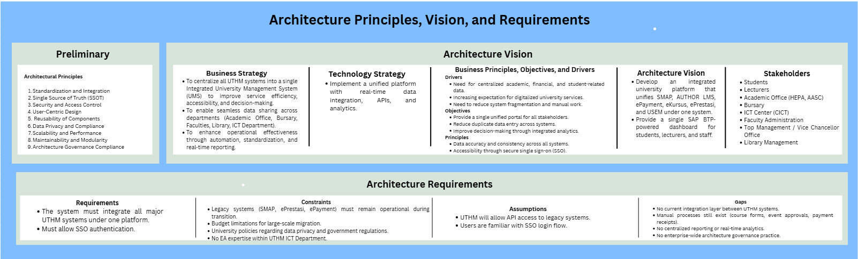Figure X
The figure x below shows the TO-BE business architecture, information architecture, and technology architecture.
The business architecture TO-BE remains the same as the business architecture AS-IS where it still focuses on improving the student experience and reducing the administrative workload. The architecture still involves the same organizational units and roles including academic, ICT, and administrative departments. In addition, the core function and services remain the same, such as Student Enrollment Service, Course Registration Service, Online Payment Service, and Academic Performance Service. This consistency that the existing business architecture is harmonized well with university’s objective where it does not require a significant change in organizational structure or functionalities.
The structure of the TO-BE information system architecture is identical to that of the AS-IS architecture, and it focuses on the ways in which data and applications help the university’s activity. Key data identities including the students, lecturers, courses, enrollment and performance records are defined in the data architecture. These entities are kept in logical darabases such as student profiles, course and curriculum and financial transaction databases with on-premises and backup systems supporting physical storage. The application architecture describes the Information System Services (ISS) which includes academic, financial and HR services, identity and access management and integration services that use API integration to link legacy systems like ePayment, ePrestasi and SMAP.
The changes from AS-IS to TO-BE technological design propose an increase in system durability, data flexibility, and continuous security monitoring. While the basic infrastructure remains focused on Tier 3 on-premises data centers in Batu Pahat and Pagoh, the TO-BE architecture incorporates offsite recovery to assure business continuity and data availability during local disasters, which is a significant improvement over the present system. The platform and middleware layer transition from a standard relational environment (MySQL) to a multidimensional structure model with the addition of MongoDB (NoSQL). This modification enables the institution to manage unstructured data more efficiently, such as research data. Furthermore, the usage of VMware for virtualization and Apache for web serving results in a more resilient and scalable hosting environment than the present basic web application architecture. The network and security layers get major performance and monitoring improvements. The TO-BE architecture includes load balancers to manage large traffic levels and VPN capabilities to provide secure remote access to the university community. Most significantly, the security infrastructure is improved by the implementation of Security Information and Event Management (SIEM), which enables real-time threat detection and monitoring while supporting the university's current firewalls and Web Application Firewall (WAF).

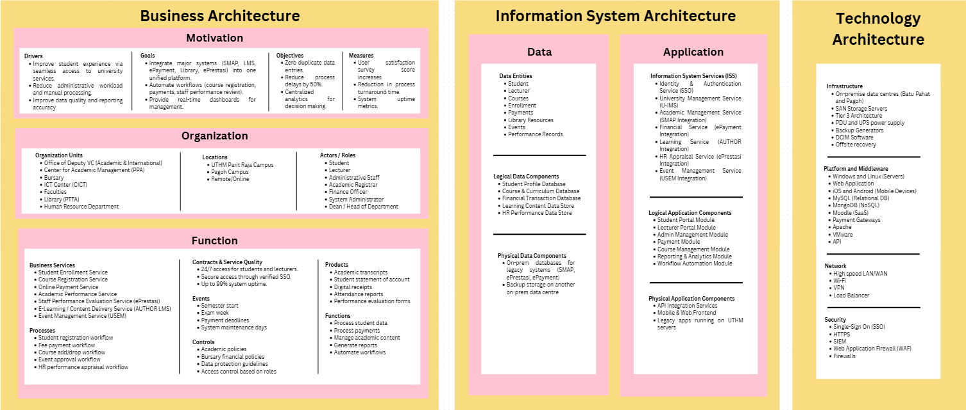
The figure XX below presents the future direction of UTHM’s enterprise systems. In this architecture, the focus in on modernization, integration, and digitalization. New solutions such as API integration development, SAP BTP configuration, and a unified U-IMS portal are introduced. These solutions aim to improve system connectivity, reduce manual work, and provide better user experience for students and staff. Data is managed more centrally, which helps improve reporting, data accuracy, and decision-making.
For migration planning, the TO-BE architecture outlines a clearer and more structured roadmap. The work packages include module migration, system development, testing, training, deployment, and monitoring. This ensures that systems changes are done step by step without disrupting daily university operations. The contracts section becomes more detailed by including compliance checkpoints, non-functional requirements such as security and privacy, and clear deliverables. Overall, the below figure shows how UTHM can move from a partially integrated environment to a fully digital, secure, and well-managed enterprise system that supports long term growth and digital transformation.
Figure XX illustrates the Implementation Governance framework for the EA TO-BE, which establishes a clear set of rules to ensure all new IT projects are consistent and secure. The framework is divided into three main areas which are standards, guidelines, and specification. The standards section requires all new developments, such as the U-IMS portal, to follow the university’s main business and technology plans while meeting strict security and data protection rules. By setting these standards, UTHM can ensure that different systems can talk to each other using approved integration methods rather than working in isolation.
To build better systems, the guidelines provide practical advice on creating modular and reusable designs. This approach helps the university avoid building the same features multiple times and ensures that data remains consistent across different departments. These guidelines also emphasize a common user experience, ensuring that students and staff encounter a familiar interface when moving between different university services.
Then, the specification area ensures that every project is properly documented before it is launched. This includes creating detailed maps of how data flows, how applications are structured, and how the technology will be hosted and monitored. By following this structured governance model, the university can safely migrate legacy systems like SMAP and ePayment into a modern environment while meeting its goal of improving digital services by 2030.

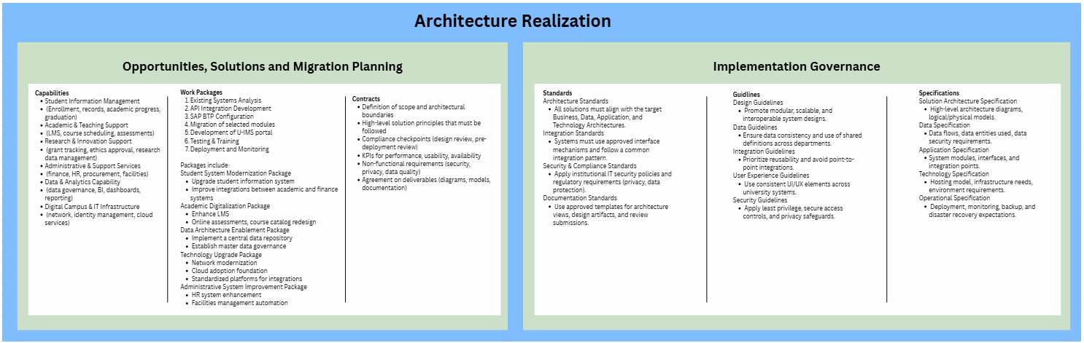

4.8.5 SYSTEM ARCHITECTURE
Figure 4.x shows the cloud system architecture designed for the system. Since the applications are developed using a cloud platform called SAP Build Apps, the system uses cloud-based architecture.

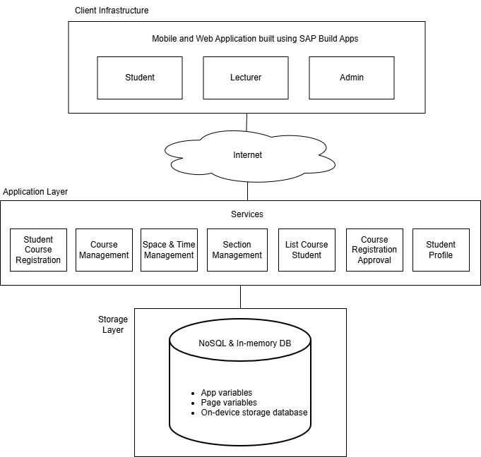
Figure 4.x Cloud System Architecture for the System

4.8.6 COMPONENT OF SYSTEM ARCHITECTURE
The three user's role which are Student, Lecturer, and the Admin can access the applications through their web browsers and mobile devices. Students use the system for registering for courses and viewing student profile. Lecturers access the system for viewing student lists and approving student course registration. Admins use the system for managing course and section and allocating time schedules and location for courses. This layer communicates with the backend through the Internet.
The Application layer shows the Services provided in the system. The services including registering courses and the approval process, viewing profile, and managing courses and sections details, class schedules, and class location.
The system uses NoSQL and in-memory database type. The main data component used are the app variable, page variable, and the on-device storage database. The app and page variables are temporary data stored when the application is running, while on-device storage database is a database that allows some data to be stored locally on user’s device when the application offline.

4.8.7 PROJECT DESIGN
This section details on the system design using use case diagram along with its description that details on showing how users (actors) interact with a system to achieve goals UML diagrams such as activity and sequence diagram to see process flow and how components of the system interact with each other. An ERD diagram is shown to detail on data entity that is involved within the system. Finally, user interface design provides a planned layout on how the system would look like to the users to ensure that it is intuitive and properly structured.

4.8.7.1 USE CASE DIAGRAM
Figure x shows the use case diagram of the Student Profile Management module. The diagram consists of a main actor which is Student. The table below shows the alias used for all of the use cases within the module.
Use Case | Code
Change Password | UC1
Update Student Profile | UC2
View Student Profile | UC3
View Registered Course | UC4

Table x: Use Case Code Mapping
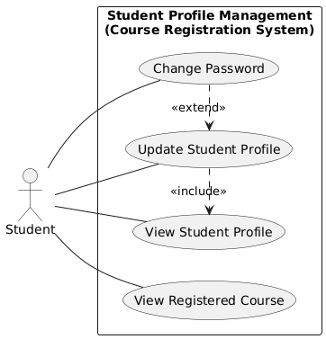
Figure x: Use Case Diagram of Course Registration System (Student Profile Management Module)

Student is able to Change Password UC1), Update Student Profile (UC2) and View Student Profile (UC3) and View Registered Course (UC4). UC3 is the main component of the diagram as other use cases includes it to complete its own thus the “<<include>>” notation. Other than that UC2 is extended from UC3 meaning that use case is optional UC3 is executed.

4.8.7.1 USE CASE DESCRIPTION

Use Case Name | Change Password (UC1)
Primary Actor | Student
Goal | Allow a student to securely change their login password.
Preconditions | Actor is logged in, profile exists and current password is known.
Main Flow | 1. Student selects “Change Password”.  2. System prompts for current password.  3. Student enters current password and new password.  4. System validates and updates password.  5. System confirms success.
Alternative Flow | 2a. Incorrect current password → System displays error.  3a. Weak new password → System displays error and rejects change.
Postconditions | Password is updated and student can use the new password for login.

Use Case Name | Update Student Profile (UC2)
Primary Actor | Student
Goal | Allow a student to update their profile.
Preconditions | Student is logged in, profile exists.
Main Flow | 1. Student views the profile.  2. Student edits profile fields (name, program, year, etc.).  3. Student saves changes.  4. System validates and stores updated information.  5. System displays confirmation.
Alternative Flow | 2a. Invalid input and system displays error.  2b. Student cancels and no changes are saved.
Postconditions | Student profile is updated in the system.

Use Case Name | View Student Profile (UC3)
Primary Actor | Student
Goal | To allow a student or admin to view a student’s profile information.
Preconditions | Student is logged in and profile exists.
Main Flow | 1. Student logs into the system.  2. Student selects “View Profile” (Admin searches for student).  3. System retrieves profile data.  4. System displays profile to the actor.
Alternative Flow | 3a. Student not found → System displays “Student not found”.
Postconditions | Profile information is displayed.

Use Case Name | View Registered Course (UC4)
Primary Actor | Student
Goal | Allow a student to view all courses they are registered for in the system.
Preconditions | Student is logged in and registration data exists.
Main Flow | 1. Student selects “View Registered Courses”.  2. System queries registration table for student’s courses.  3. System retrieves course information.  4. System displays registered courses list.
Alternative Flow | 3a. No courses found and system displays “No courses registered”.
Postconditions | List of registered courses is displayed; no database changes occur.

4.8.7.2 ACTIVITY DIAGRAM
This section shows the activity diagram of each use cases visually maps out the flow of steps, actions, and decisions in a system or business process.

Change Password (UC1)
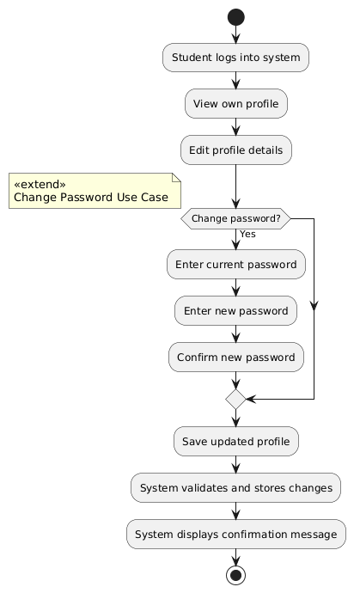
Figure x: Activity Diagram of Change Password
Figure x shows the flow of UC1. The student navigates to their profile to make updates and have the option to update the password. Any updates will then be saved and validated and prompts a confirmation message.
Update Student Profile (UC2)
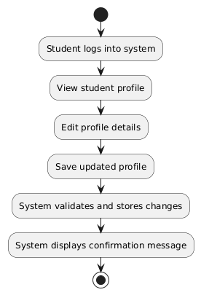
Figure x: Activity Diagram of Update Profile
Figure x shows the flow of updating students profile updating details such as phone number and personal email. The student navigates to the update page and click edit and choose fields to be updated. It can then be saved and the student will prompt a confirmation message.

View Student Profile (UC3)
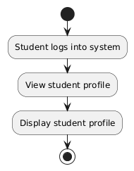
Figure x: Activity Diagram of View Student Profile

Figure x shows the view student profile page where both students can view their own profile. information such as name, matric numbers, phone numbers and personal email can be displayed in this page.

View Registered Course (UC4)
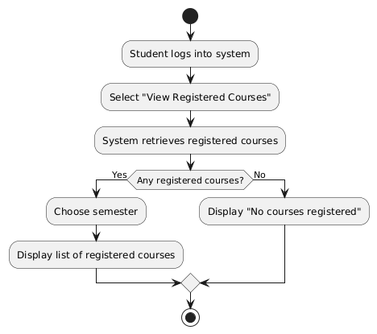
Figure x: Activity Diagram of View Registered Course

Figure x shows the activity diagram for UC4 where the system will show all the courses registered by the student based on the selected semester and prompts the user if no courses are registered.

4.8.7.2 SEQUENCE DIAGRAM
Sequence diagrams are interaction diagrams that detail how operations are carried out. They capture the interaction between objects in the context of a collaboration. Sequence diagrams are time focus and they show the order of the interaction visually by using the vertical axis of the diagram to represent time what messages are sent and when.
Change Password (UC1)
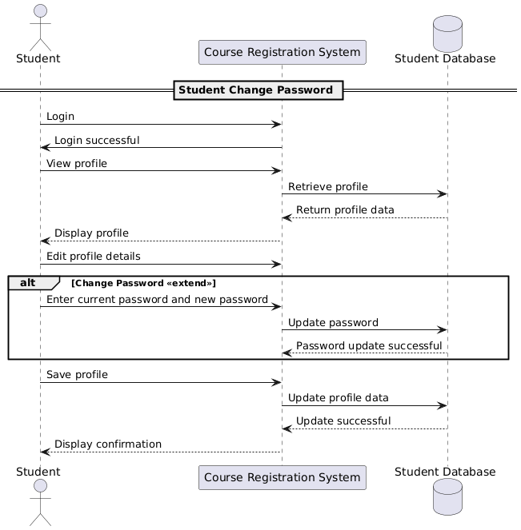
Figure x: Activity Diagram of Change Password
Figure x shows the sequence diagram of student changing password. This sequence begins with a student logging in, which retrieves and displays their profile from the student database. In edit mode, the student can optionally change their password and updates it into the database. Finally, the student saves their updated profile details, the system commits the changes to the database, and a success confirmation is displayed to the student.
Update Profile (UC2)
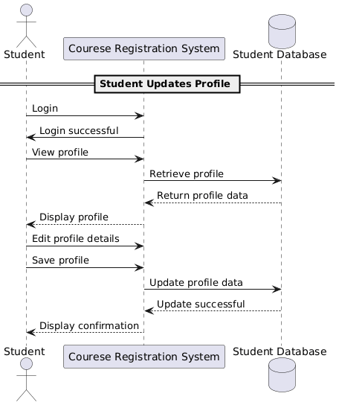
Figure x: Activity Diagram of Update Profile

Figure x shows a student updating their profile by first logging into the system, which retrieves and displays their data from the database. The student then edits and saves their profile, causing the system to send the updated data to the database. Finally, the database confirms the update, and the system displays a confirmation message to the student.
View Student Profile (UC3)
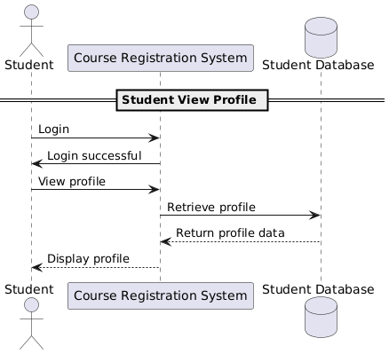
Figure x: Activity Diagram of View Student Profile
Figure x shows student viewing their profile. The student logs into the system, which retrieves and displays their current information from the database

View Registered Course (UC4)
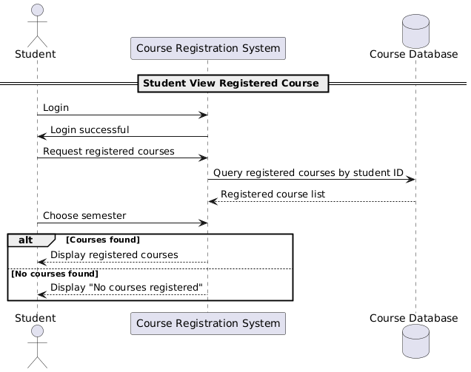
Figure x: Activity Diagram of View Registered Course
Figure x shows the sequence diagram of student changing password. This sequence begins with a student logging in, which retrieves and displays their profile from the student database. In edit mode, the student can optionally change their password and updates it into the database. Finally, the student saves their updated profile details, the system commits the changes to the database, and a success confirmation is displayed to the student.

4.8.8 DATABASE DESIGN
Figure x outlines the database structure for a registration system, centred around three tables: STUDENT, COURSE, and REGISTRATION. A STUDENT, identified by a student_id, can have multiple registration records. Similarly, a COURSE, identified by a course_id, can be included in many registrations. The REGISTRATION table serves as the link between the two, using foreign keys to connect students to courses while storing specific enrollment details like the semester and registration_date.

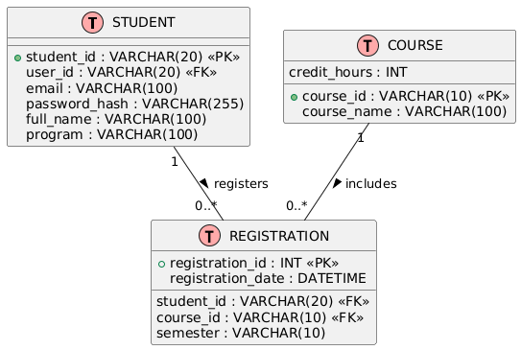
Figure x: ERD of Course Registration System (Manage Student Profile Module)

4.8.9 INTERFACE DESIGN
This section details on interface design based on all the use case that have been described. UI/UX design is crucial for creating products that are not only visually appealing but also easy to use. Good UI (User Interface) design focuses on the look and layout of a product, while UX (User Experience) design ensures that the product is user-friendly and meets the needs of the users.

Figure x: Dashboard Interface

Figure x Registered Courses Interface

Figure x: Edit Profile and Password Interface

4.9 SUMMARY
This chapter has detailed the comprehensive analysis and design of the proposed Enterprise Architecture for Universiti Tun Hussein Onn (UTHM). The study began with an analysis of UTHM’s organizational structure and current system environment, identifying critical challenges such as data silos, manual data transfer, and reliance on legacy infrastructure like SMAP and ePayment. The requirements gathering phase, conducted through interviews and site visits, highlighted the need for a unified platform to support the university’s 20230 digital transformation vision.
Based on these findings, the chapter detailed the “AS-IS” architecture to document the existing gaps, followed by the proposed “TO-BE” architecture. The proposed design adopts the TOGAP framework to restructure the Business, Data, Application, and Technology layers, ensuring better alignment between IT capabilities and UTHM’s strategic objectives. Key improvements include the introduction of a hybrid database model (combining SQL and NoSQL) to handle diverse academic data and the implementation of a robust Implementation Governance framework to standardize future IT developments. Ultimately, this chapter establishes the architectural blueprint required to transition UTHM towards a fully integrated, cloud-enabled Smart Campus environment.

CHAPTER 5
ANALYSIS AND DESIGN

5.1 INTRODUCTION

5.2 SYSTEM DEVELOPMENT

5.3 CREATE DATABASE

5.4 CODING OF SYSTEM PROCESS

5.5 SUMMARY

CHAPTER 6
CONCLUSION

6.1 INTRODUCTION

6.2 SYSTEM CONTRIBUTION

6.3 SYSTEM CONSTRAINT

6.4 FUTURE SUGGESTION

6.5 SUMMARY

REFERENCES

Amin, F. A., Hussein, S. S., Daud, N. A., Bakar, N. a. A., & Ahmad, W. a. Z. W. (2024). Cultivating excellence: a case study of enterprise architecture transformational journey in higher education. Indonesian Journal of Electrical Engineering and Computer Science, 34(1), 548. https://doi.org/10.11591/ijeecs.v34.i1.pp548-555
Astri, L. Y., & Gaol, F. L. (2013). Information System Strategic Planning with Enterprise Architecture Planning. CommIT (Communication and Information Technology) Journal, 7(1), 23-27.
Hashim, N. M. Z., & Mohamed, S. N. K. S. (2013). Development of student information system. International Journal of Science and Research (IJSR), 2(8), 256-260.
Hindarto, D. (2023). Supporting University Management System Digital Transformation with Enterprise Architecture. Jurnal JTIK (Jurnal Teknologi Informasi Dan Komunikasi), 7(4), 696–706. https://pdfs.semanticscholar.org/5904/9ee560639d1e454b7f9a41497e24fa9cb4bb.pdf
Imke Vierjahn. “SAP BTP Use Cases: Going Deeper, Broader, and Faster.” SAP News Center, 16 Oct. 2023, news.sap.com/2023/10/sap-btp-use-cases-deeper-broader-faster/
KAUST Transforms Campus to Smart City with SAP Business Technology Platform. (n.d.). SAP AppHaus. https://apphaus.sap.com/project/kaust-transforms-campus-to-smart-city-with-sap-business-technology-platform
Lamey, A., Abdelkader, H., Keshk, A., & Eletriby, S. (2023). A realistic and practical guide for creating intelligent integrated solutions in higher education using enterprise architecture. Sustainability, 15(11), 8780. https://www.mdpi.com/2071-1050/15/11/8780
Manuhutu, M. A., Uktolseja, L. J., & Gaspersz, S. (2018). Academic Information System for Student (Case Study: Victory University of Sorong). International Journal of Computer Applications, 180(43), 26-33. https://www.researchgate.net/profile/Melda-Manuhutu-2/publication/329362873_Academic_Information_System_for_Student_Case_Study_Victory_University_of_Sorong/links/5c04b1ec45851523d159b34b/Academic-Information-System-for-Student-Case-Study-Victory-University-of-Sorong.pdf
Meutia, N. S., Sulistiyani, E., Budiarti, R. P. N., & Sari, R. (2022). Enterprise Architecture Framework in Higher Education: Systematic Literature Review. Applied Technology and Computing Science Journal, 5(2), 112–118. http://journal2.unusa.ac.id/index.php/ATCSJ/article/download/3751/1950
Nama, G. F., & Kurniawan, D. (2017). An enterprise architecture planning for higher education using the open group architecture framework (TOGAF): Case study University of Lampung. In 2017 Second International Conference on Informatics and Computing (ICIC) (pp. 1–6). IEEE. http://repository.lppm.unila.ac.id/5946/1/023.pdf
Navaz, A. S., Fiaz, A. S., Prabhadevi, C., Sangeetha, V., & Gopalakrishnan, S. (2013). Human Resource Management System. arXiv preprint arXiv:1309.5351. https://arxiv.org/pdf/1309.5351
Nendrambaka, N. S. K. (2024). Recent advances and innovations in SAP S/4HANA Cloud and SAP BTP and SAP AI: integration strategies and latest developments. International Journal of Scientific Research in Computer Science Engineering and Information Technology, 10(6), 1743–1751. https://doi.org/10.32628/cseit241061219
Poisl, T. (2023, December 2). Exploring SAP BTP Reference Architecture To Master Multi- Cloud And Platform Environments. SAPinsider. https://sapinsider.org/event-presentations/exploring-sap-btp-reference-architecture-to-master-multi-cloud-and-platform-environments/
“SAP Business Technology Platform: With Use Cases back to Its Roots and into the Cloud.” SAP News Center, 28 Oct. 2022, news.sap.com/2022/10/sap-btp-use-cases-in-cloud/
Setiawan, R. (2018, November). Architecture of human resource management system at universities. In IOP Conference Series: Materials Science and Engineering (Vol. 434, No. 1, p. 012258). IOP Publishing. https://iopscience.iop.org/article/10.1088/1757-899X/434/1/012258/pdf

